UCAS reference

Info. for teachers

The reference form is an important part of a student's UCAS application, alongside their achieved grades, predicted grades and personal statement. Universities are looking for students who not only fulfil academic requirements but also demonstrate the relevant skills, personal motivation and a genuine interest in the subject they are applying for.

Writing the reference – general guidance
It is important to work with the applicant to ensure the personal statement and reference are not repetitions of each other and meet their own objectives.
- The personal statement should address the student’s academic interest in the subject area they wish to study.
- As a referee, you are aiming for the reference to provide universities with an informed and realistic academic assessment of a student’s suitability for their chosen programme of study. The reference provides additional information about the student beyond the predicted grades e.g. further information about a student’s academic skills and qualities and any disadvantage or particular circumstances the student may be facing.

Before you start writing the reference – some guidelines
- Read the whole UCAS application so that you have a comprehensive understanding of the applicant’s 5 chosen programmes, academic interests, preferred institutions and any longer-term goals or aspirations. Only one reference is written for all 5 choices.
- The UCAS reference now consists of 3 sections: A general statement about the school, information about extenuating circumstances, and other specific supportive information about the applicant.
- The first section is an opportunity to provide some general contextual information about the school or college, such as performance, intake demographics, or progression rates to Higher Education. It could also include details of your portfolio of qualification provision (including any restrictions), any significant changes that may have had an effect on the applicant (e.g. staff changes), and any policies or processes related to predicted grades (e.g. internal assessments).
- If the student’s achieved or predicted grades have been impacted by their personal circumstances, you should provide details in the second section of the reference. Details of extenuating circumstances can also be provided in our Extenuating Circumstances Form.
- The third section should be used to focus on a student's academic performance and potential in subjects relevant to the programme they are applying for. This could include feedback from subject teachers, and/or comparisons within current or previous school cohorts.
- When writing a reference for any applicant please remember that – under the Data Protection Act 2018 – the applicant can ask for a copy of the reference and any other personal information we have about them.
- If you are writing a reference for a degree you are unfamiliar with, you can find information about LSE’s undergraduate programmes, entry requirements, and the skills and attributes we are looking for in a student on our programme pages.
- References can include information written by multiple teachers but should be compiled or edited together by one person.
- It is important that you produce the reference from a professional school email address. If this is not possible, please clarify this.
- The reference should not exceed 4,000 characters (including spaces) or 47 lines (including blank lines), whichever is the shorter.
The above info is from this LSE link that I found useful:

https://www.lse.ac.uk/study-at-lse/Undergraduate/Prospective-Students/How-to-Apply/Completing-the-UCAS-form/Reference?_gl=1%2A10ilu62%2A_ga%2AMTQ5NDE5NDA0OC4xNzA2MDMzMzAz%2A_ga_LWTEVFESYX%2AMTcwNjAzMzMwMy4xLjEuMTcwNjAzMzMxNi40Ny4wLjA&fbclid=IwAR38AGB-IKg28cZaR-SHaR3nictkJ4NXb55x4tUacSbnuFDU2qn98lc48_c

The link will lead to you to more guidelines (as shown below) to complete the reference form:
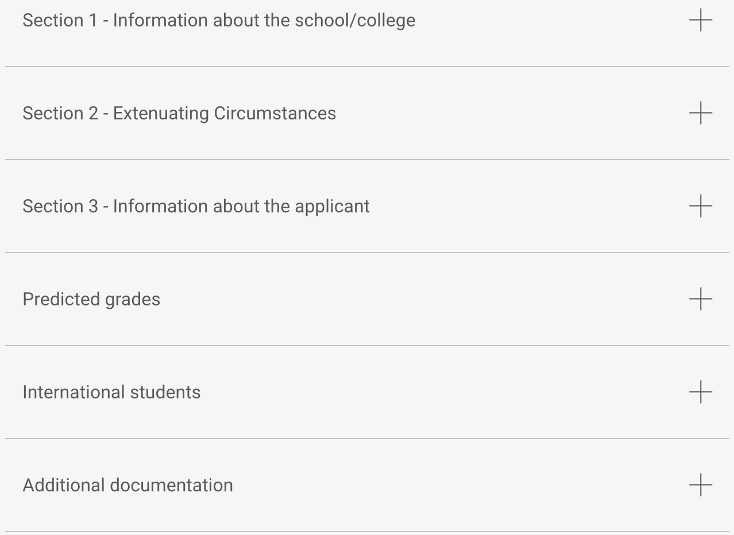

Hope you find the above helpful.

For 2024 Entry

